Chapter 19, Problem 75.

For the individual two-ports shown in Fig. 19.121 where

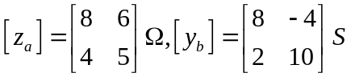

- Determine the y-parameters of the overall two-port.
- Find the voltage ratio V_{o} / V_{i} when Z_{L} = 2Ω.

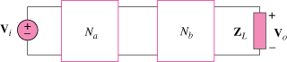

Figure 19.121
For Prob. 19.75.

